Grant application form (Annex A)

D4D Grants

by the EU Global Diaspora Facility
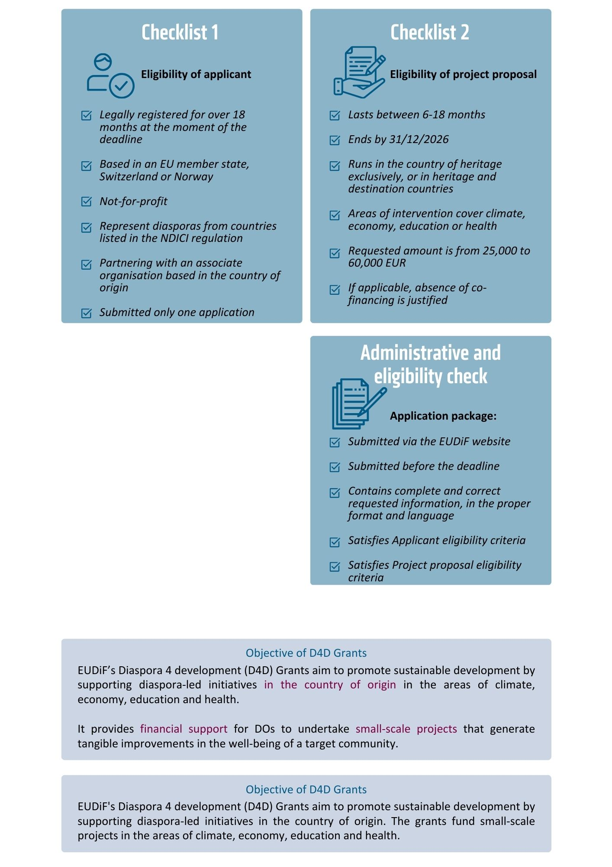
Please read the Call for applications guidelines carefully before filling this form.
The application form is structured as follows:
- Section A: Applicant and associate organisation information
Provides basic and contact information about your organisation and the associate organisation involved in the project.
Section B: General features of your project
Outlines the general overview of your project, including its title, timeline, budget, geographic scope, and target groups.
- Section C: Detailed description of your project
Describes the problem your project addresses, the proposed solutions, and how you plan to implement them. The section details your project's objectives, activities, expected results, challenges, and cross-cutting elements.
- Section D: Strategic alignment
It requires you to demonstrate alignment with your organisation's mission, vision, and objectives, as well as showcase your capacity to successfully implement and sustain the project.
- Section E: Other
Provides additional remarks and lets us know how you heard about this call.
Thank you for your interest in D4D Grants and best of luck with your application!
If you have questions, please submit them via the EUDiF website.

Section A: Applicant and associate organisation information

The lead applicant
Full name of your organisation – 250 characters

The organisation is:

The organisation represents diaspora from the following country(ies): 250 characters

Representation of diaspora in your organisation – 1000 characters
Describe what characterises your organisation as a “diaspora organisation” by referring to your board or member composition, management structure, your projects and activities focus and other elements that may be relevant.

Legal representative
Name – 100 characters

Position – 100 characters

Email – 100 characters

Telephone – 100 characters

Project lead (If different from above)
Name – 100 characters

Position – 100 characters

Email – 100 characters

Telephone – 100 characters

Other information related to the lead applicant are collected in the other annexes of the grant application package.
The associate organisation
Full name – 250 characters

Type:

Other, please indicate:

Date of establishment – 100 characters

Complete address – 400 characters

Email – 100 characters

Telephone – 100 characters

Website and social media – 400 characters

Objectives of the organisation – 400 characters

Main activities – 400 characters

Main contact person in the associate organisation
Name – 100 characters

Position – 100 characters

Email – 100 characters

Telephone – 100 characters

Partnership
Joint objectives/activities – 400 characters

Section B: General features of your project
- Title of your project – 100 characters

- Intervention area (multi-select option)
Climate
Economy
Education
Health

- Budget
  - Total budget of the project in euros – 10 characters

  - Requested contribution from D4D Grants in euros (from €25,000 to €60,000) – 10 characters
The answer will be different from 3.1 if you are requesting a contribution from D4D Grants that is less than the total budget of your project. The requested contribution cannot exceed the total budget of the project.

  - If you are requesting contributions from D4D Grants equivalent to 100% of the total project budget, please provide a justification– 1000 characters
Should the requested contribution be lower than 100%, you must detail the source(s) in the Budget (Annex B).

- Duration
  - Duration of the project in months
months
  - Duration of the component funded by D4D Grants if different from 4.1. in months
It should be between June 2025 and December 2026.
months
- Geographic scope – 400 characters
Provide as much detail as possible on where you will conduct your activities.

- Direct and indirect target groups/final beneficiaries – 400 characters
Including numbers and a segregation by gender and by other aspects if applicable.

Section C: Detailed description of your project
Background (1000 character per response)
- Needs the project will address
Describe the specific problem, provide context and current/baseline information (including relevant figures if applicable), and explain how you identified it.

- Solutions you propose to address the needs
The solution and its expected impact at the very end of the project and on the longer term.

- Building on past and ongoing initiatives and lessons learned
Explain how your proposal sits within the national, regional and international development context. It should leverage previous and current initiatives and integrate lessons learned. It is important that your proposal complements past and ongoing initiatives of other stakeholders and does not duplicate them.

Approach
- Articulate your solution into one “general objective” statement and up to five “specific objective” statements
General objective – 400 characters

Specific objectives 1 to 5 – 1500 characters
List objectives that are specific, measurable, achievable, relevant and time-bound.

How will you achieve these objectives? (400 characters per response)
Activities
The information in this section will be used to create the Logical Framework that will become part of the Grant contract package should your proposal be successful.
Include up to ten activities by copying the below block of text from “Activity #” until “Required resources”. It is recommended that you link each activity to a specific objective and include at least two activities per specific objective.
Activity # X – Title: 100 characters
Description
What you will do to reach the results, this will include using resources (human, material and financial). Mention whether it will be implemented online or on site.
400 characters
Duration of activity in weeks: X
Expected results
Mention baseline values or situation, and target values. Think about tangible outputs, products, services, and results you hope to achieve by implementing the related activity. You should be able to portray them as achievable indicators that you can measure in the future to ensure your implementation is on track.
400 characters
Role of each actor
State the role of each actor within this activity: your organisation, the associate organisation, and any other relevant stakeholders. Explain any collaboration mechanisms included.
400 characters
Required resources
List the necessary resources (human, financial, material) and quantify them.
400 characters

---- Insert next activity block here ----

Timeline Summary
Use the “Shading" function to colour the cells corresponding to your proposed implementation timeline. Highlight the timeline for your proposed activities (up to ten). The existing shading is only a guide, so please remove it before adding your timeline
Activity | Q1  Months 1-3 | Q2  Months 4-6 | Q3  Months 7-9 | Q4  Months 10-12 | Q5  Months 13-15 | Q6  Months 16-18
Activity 1: Title of activity
Activity 2: Title of activity
Activity 3: Title of activity
Activity 4: Title of activity
Activity 5: Title of activity
Activity 6: Title of activity
Activity 7: Title of activity
Activity 8: Title of activity
Activity 9: Title of activity
Activity 10: Title of activity

- Challenges/risks to implementation and how you aim to mitigate them
The challenges need to be relevant to the implementation phase of your project, list up to three.
Challenges | Mitigation measures
Challenge 1 – 250 characters | Mitigation measure 1 – 250 characters
Challenge 2 – 250 characters | Mitigation measure 2 – 250 characters
Challenge 3 – 250 characters | Mitigation measure 3 – 250 characters

- Describe the cross-cutting elements in your proposal – 1000 characters
Examples of cross-cutting elements include a thought-out gender approach, promotion of human rights, solutions for vulnerable target groups such as people with disabilities, promotion of youth, innovation, best practices, new approaches, action at the local level, collaboration with the private sector, solutions for the environment, etc. Discuss the anticipated impact of these elements and how you believe they will contribute to the project’s success

Section D: Strategic alignment (1000 characters per response)
- Explain how the project you propose matches your organisation’s priorities.
Explain your organisation’s mission, vision, objectives and/or core areas of work and how the proposed project aligns with and contributes to achieving them.

- Explain how the proposed activities match your organisation’s capacities to implement them.
Provide examples of previous similar projects and their outcomes to demonstrate your experience. Detail your organisation’s capacity, including human, technical, and financial resources, that will ensure the successful implementation of the project.

- Clarify how you will ensure proper monitoring and reporting of activities, finances and results during the project.
ICMPD requires regular reporting during the implementation of the project, according to the Grant Contract Package. Identify how you will meet the requirements (e.g., by identifying the individuals responsible and the underlying processes for such tasks and by explaining how you will track the implementation, including financial expenditures, to maintain accountability).

- Explain how the diaspora is involved and the unique benefits they bring to this project.
Discuss the unique strengths, skills, and perspectives that the diaspora community offers. Highlight specific experiences, networks, or other aspects that the diaspora brings to the table. Explain how these unique benefits will enhance the project’s effectiveness and overall impact, without repeating the organisation's capacity discussed in the previous question.

- Elaborate on how you will sustain the results of the activities after EUDiF support for the project is complete.
Explain your sustainability plan, including how you will continue to support the project after the grant period ends. Discuss the human, institutional, technical, and financial resources available, and outline any capacities that will contribute to long-term sustainability. Address how follow-up activities will be financed and how future operating and maintenance costs will be covered. Include details on institutional capacity, local ownership, potential policy impacts (e.g., improved legislation or methods), and environmental effects of the project.

Section E: Other
- Other remarks – 1000 characters

- How did you hear about this call?
EUDiF website
Email from EUDiF
During an EUDiF event
EUDiF Twitter page
Bilateral meeting
Word of mouth
Search engine
LinkedIn
Other, please specify:

Full name Date Signature



